

**The Absence of Mental Health Education in Secondary Schools:**

**A Proposal for Additional Resources & Instruction**

Prepared for:

Thames Valley District School Board

Prepared by:

Oakridge Secondary School

Physical Education Department

November 22nd, 2022

Oakridge Secondary School

1040 Oxford St W

London, ON N6H 1V4

November 22nd, 2022

Mark Fisher

Director of Education

Thames Valley District School Board

1250 Dundas St

London, ON N5W 5P2

Dear Mr. Fisher:

Subject: Demand for More Education on Mental Health

The Oakridge Secondary School Physical Education Department have created this report analyzing a primary source and two secondary sources regarding the insistence for more education for mental health.

We have multiple supported sources that provide significant information in an organized and concise manner and believe will be effective in persuading you to allocate resources into mental health education.

This report is quite important to not only our department, but to every school globally. Since the COVID-19 pandemic and school closures, the students have no guidance regarding their own mental health. Moreover, staff do not have sufficient training to offer guidance. We would like to thank Diane Galbraith, for the opportunity to interview them. If you have any future inquiries regarding the report, we would be more than happy to speak more about it. You can contact Roman Naghshi, who can be reached by phone at 519-888-8888.

With Gratitude,

Roman Naghshi

Secondary School Educator

**Introduction:**

The pandemic of coronavirus disease 2019 (COVID-19) and the social distancing measures implemented by a number of countries have disturbed daily activities. According to UNESCO, “as of April 8, 2020, schools were closed in 188 countries worldwide, and more than 90 percent of registered students (1.5 billion young people) were out of school globally” (Lee, 2020). Audrey Azoulay, director-general of UNESCO, cautioned that “...the global extent and pace of the present educational disruption is unprecedented” (Lee, 2020).

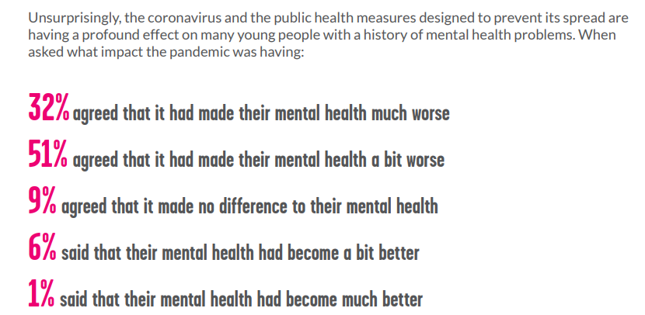

Such closures deny students with mental health difficulties access to the typically provided school-based resources (Lee, 2020). In a survey undertaken by the mental health organisation, YoungMinds, included 2,111 persons up to the age of 25 in the United Kingdom with a history of mental illness, 83% said the pandemic has exacerbated their conditions (See Figure 1) and 26% of respondents were unable to access mental health support (Lee, 2020).

Figure 1: Students being asked what impact the

pandemic was having (Young Minds, 2020)

School-based routines are key coping mechanisms for students with mental health issues, as without it students may lose their feeling of stability and may suffer a resurgence of their symptoms (Lee, 2020). Prior to the pandemic, “some children with depression found it difficult to attend school, but at least they had school routines to stick to, according to a trained clinical psychologist in Hong Kong” (Lee, 2020). “Some children hide in their rooms for weeks after school has ended, refusing to shower, eat, or leave their beds” (Lee, 2020). Currently, some students with depression are suffering from significant difficulties re-adjusting to ordinary life again.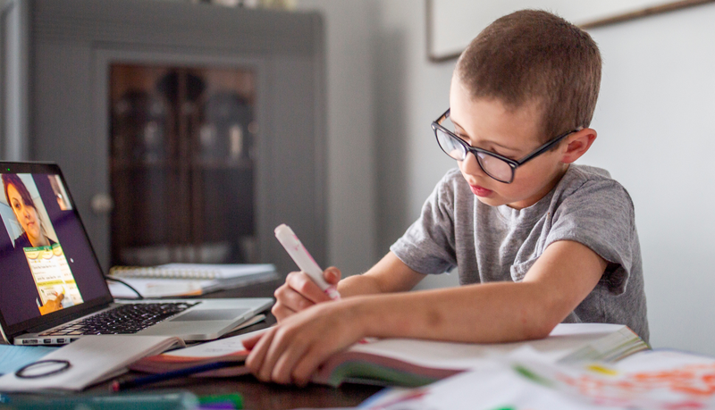

Figure 2: Student Virtually Interacting With Teacher

**Analysis:**

During the conversation with Diane Galbraith, a Registered Social Worker at Galbraith Counselling and Therapy, they observed that many of their clients explain how they may be suffering from a mental health disorder. Galbraith continued to explain that, in reality, their clients are suffering from stress, and that they are not informed on the differences between stress and mental health illnesses. I proceeded to inquire as to what measures may be taken to enhance the mental health of prospective clients and how to possibly enable them to continue living without the unnecessary dependence of counselling sessions. Galbraith provided an explanation as to how to educate them on various methods of relaxation, as well as informing them that stress is a symptom of mental health illnesses but is not the only indication of such disorders. Education concerning mental health can definitely be provided to students in high school, particularly in the required Physical Education course taken during the ninth grade. To continue, it is not outside the realm of possibility to restructure a handful of the approximately 75 class periods that children spend participating in physical education in order to educate and raise awareness about mental health issues. In addition, the material may be evaluated, and it not only has the potential to raise students' grades but also to improve their day-to-day life.

To continue on the topic of the requirement of such a shift are the findings from a literary evaluation that was undertaken by Viner, et al. (2022), which included 36 studies from 11 different nations. This analysis included a total of 79 781 children and adolescents together with 18 028 parents. “These studies took place during the first wave of the COVID-19 pandemic, which lasted from February 2020 to July 2020” (Viner, et al., 2022). Twenty-five of the 36 research (or 69%) that focused on mental health found connections between emotional, behavioural, and restlessness/inattention issues (Viner, et al., 2022). “Moreover, of the 25 findings, the conducted testing led researchers to the conclusion that between 18% and 60% of children and adolescents had scores that were over the risk thresholds for distress, particularly anxiety and depressive symptoms” (Viner, et al., 2022). In addition, the study found that there was “...an increase in the amount of time spent in front of screens and using social media, while there was a drop in the amount of time spent being physically active” (Viner, et al., 2022). All of these things have the potential to influence the students' behaviours and their mental health.

**Conclusions:**

It is possible for anybody to experience stress or other related mental health concerns, and learning about mental health has advantages not just for students but even for teachers, as well. In a study that was carried out by Kutcher et al. (2013), the researchers created a program to educate teachers on mental health literacy. Then, they surveyed the participants and evaluated the outcomes. There were 83 educators in attendance at the training, and the findings of the questionnaires that were filled out by 79 of those educators were included in the overall research (Kutcher et al., 2013). In the survey, there was evidence of “...considerable improvement in the levels of knowledge as well as attitudes shown by the respondents” (Kutcher et al., 2013). The average score on the exam measuring general mental health knowledge increased by 15 percentage points between the beginning and the end of the training (Kutcher et al., 2013). In addition to this, there was less of a disparity in the average scores that were obtained on the examination (Kutcher et al., 2013). In summary the findings of this study, in order for schools to be able to conduct effective mental health promotion and prevention programmes, such as the ones that fall within our authority, the knowledge and attitudes of the instructors need to be strengthened. Figure 3: Educator scores on mental health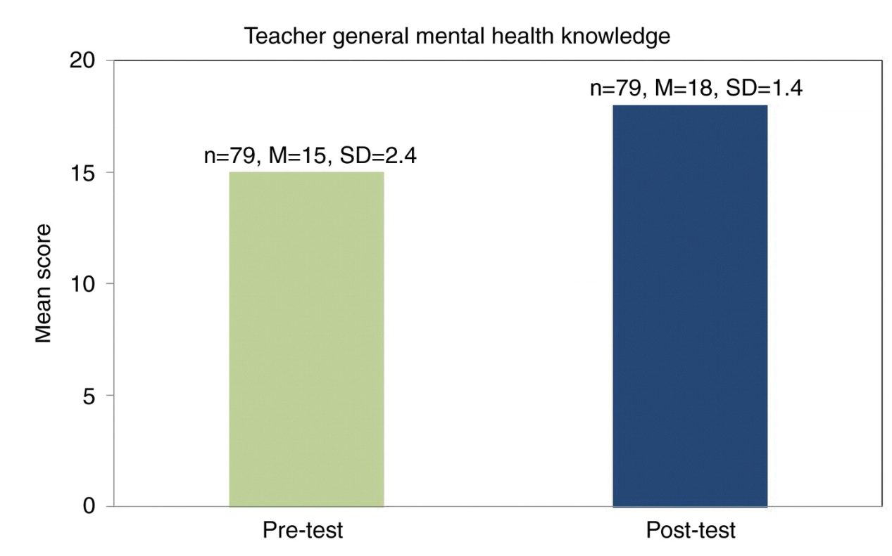

knowledge test (Kutcher et al., 2013)

To summarize the findings from the studies and the information from Diane Galbraith, the COVID-19 pandemic has not only impacted the lives of the students but everyone. In addition, counsellors such as Galbraith have found it more challenging to deal with clients that do not want to comprehend that they do not suffer from mental illness. To not only reduce their stress load, but aid our own students' mental health, we should highly consider incorporating mental health education into the Grade 9 Physical Education curriculum. Without these changes, there could be long term impacts on the futures of our students regarding employment, education, relationship, satisfaction of life and much more. It is our responsibility in the education discourse community to lead by example and push to be the highest quality school board. We at the Oakridge Secondary School Faculty of Physical Education have not only the school board in mind but the students in mind and want the best for everyone.

**References**

Lee, J. (2020). *Mental health effects of school closures during COVID-19.* The Lancet Child; Adolescent Health, 4(6), 421. https://doi.org/10.1016/s2352-4642(20)30109-7

Viner R, Russell S, Saulle R, et al. (2022). *School Closures During Social Lockdown and Mental Health, Health Behaviors, and Well-being Among Children and Adolescents During the First COVID-19 Wave: A Systematic Review*. JAMA Pediatr. 2022;176(4):400–409. doi:10.1001/jamapediatrics.2021.5840

S. Kutcher, Y. Wei, A. McLuckie & L. Bullock (2013) *Educator mental health literacy: a programme evaluation of the teacher training education on the mental health & high school curriculum guide*, Advances in School Mental Health Promotion, 6:2, 83-93, DOI: 10.1080/1754730X.2013.784615

Young Minds. (2020). *Coronavirus: Impact on young people with mental health needs.* https://www.youngminds.org.uk/media/xq2dnc0d/youngminds-coronavirus-report-march2020.pdf